**North Star 240 Whole School Careers Plan**

**Strategic Vision**

All students at North Star 240 will experience a scaffolded careers programme enabling them to be fully equipped with the skills needed by further education and employers, preparing them for adulthood. All students will achieve their true potential whilst being fully prepared for their transition into the ever-changing world of work.

The intent of our Careers Curriculum at NorthStar is to provide a stable careers programme where all students are provided with the opportunity to prepare for their transition into the evolutionary world of work. We intend to raise their aspirations, improve social mobility, develop eight employability skills and enhance knowledge of labour market information whilst providing them with the access to meaningful and suitable career pathways. Students will experience a range of encounters tailored to their individual needs and circumstances which will include encounter of workplaces, and employers, an insight into further education establishments and opportunities for personal guidance. NorthStar has a statutory duty to adhere to the Careers Strategy and the Statutory Guidance published in January 2018 and is working towards achieving the eight Gatsby Benchmarks.

Our careers programme is an inclusive, broad and balanced programme of careers education and personal development that provides young people of all abilities with the opportunity to ‘learn by doing’ in class, throughout school, in the local community and by access to a range of specialist professionals who can meet students individual needs.

**Gatsby Benchmarks-The Current Picture**

In 2018, the government released a new careers strategy and statutory guidance for schools and colleges. It put an increased focus on using the Gatsby Benchmarks as a framework for best practice around which we can build our own careers provision.

The eight Gatsby Benchmarks of Good Career Guidance:

1. A stable careers programme

2. Learning from career and labour market information

3. Addressing the needs of each pupil

4. Linking curriculum learning to careers

5. Encounters with employers and employees

6. Experiences of workplaces

7. Encounters with further and higher education

8. Personal guidance

In the 2023-24 academic year, we thought it would be helpful to provide an overview of the current position of CEIAG as evidenced by the Compass self-evaluation against the Gatsby benchmarks in July 2023 on the left and in our recent evaluation in March 2024 on the right below.

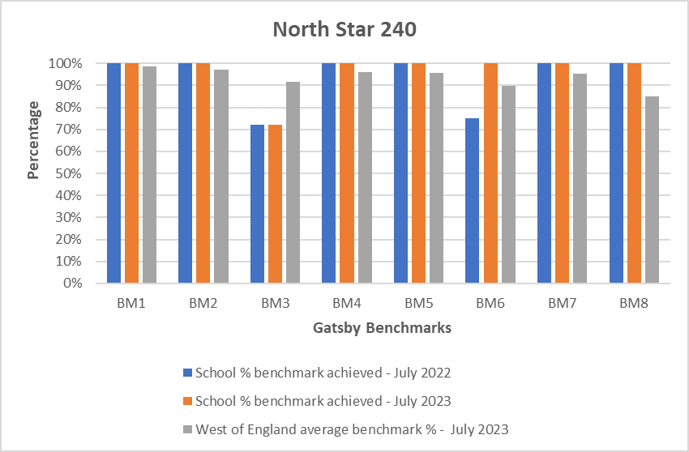

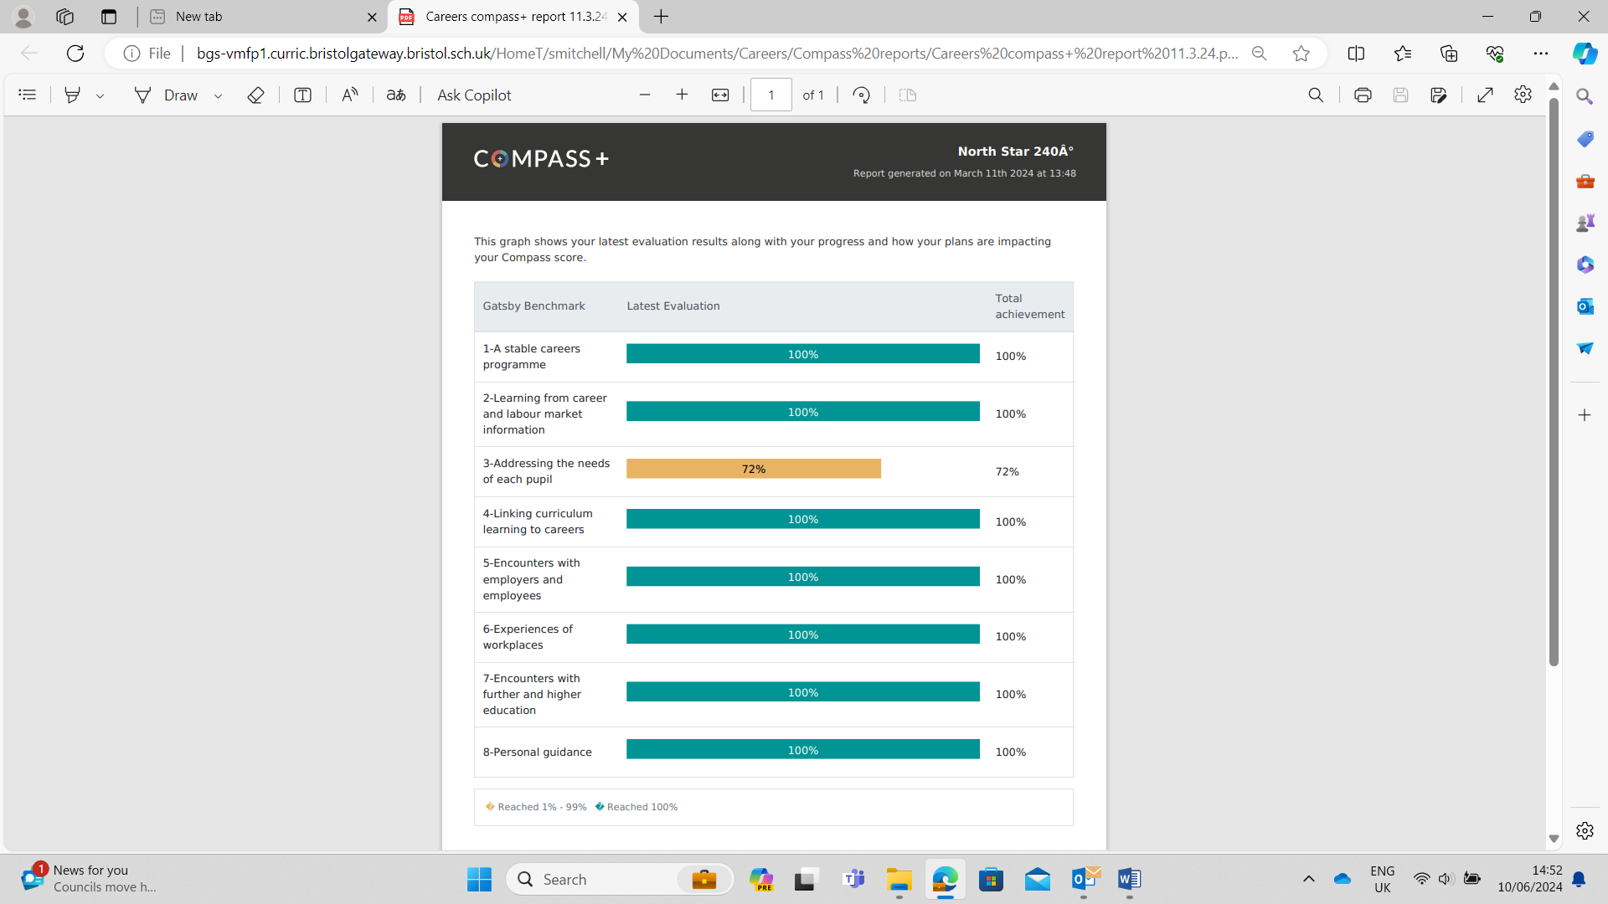

**Destination Data**

**The eight Gatsby Benchmarks of Good Career Guidance:**

1. A stable careers programme

2. Learning from career and labour market information

3. Addressing the needs of each pupil

4. Linking curriculum learning to careers

5. Encounters with employers and employees

6. Experiences of workplaces

7. Encounters with further and higher education

8. Personal guidance

**The Careers Team**

For further information about our careers provision please see our Careers Policy and Access Policy.

We will review this Careers Plan on an annual basis.

Scott Mitchell-Careers Leader

Andy Gowell-Strategic Leader

Irina Lazar-Trust Leader

Danielle Haskings - Enterprise Advisor

**Strength of Careers Provision SWOT**

|  |  |
| --- | --- |
| **STRENGTHS**   * Experienced Enterprise Adviser in place * Careers Leader in place * Careers & PSHE scheme of work in place * Extensive programme of events / activities * Extensive database of volunteers * Compass + completed by Scott Mitchell Careers Hub team * Strong relationship and support network with CEC * Established links with a range of post 16 training providers * Careers Leader networking with colleagues in other schools * Careers Leader CPD * Checking of visitor delivery information for safeguarding e.g. PREVENT * Development of KS4 work experience program with local and national employers | **AREAS TO DEVELOP FURTHER**   * Student tracking of their career’s experiences * Impact of events to be evaluated to assess effectiveness * Destinations collected but data not analysed in depth to inform whole school strategy * 1:1 careers guidance impact and follow up with tutors * Careers in the Curriculum to be developed * Regular audit of careers activities across school * Updated Careers and LMI information on school website * More employer engagements with students in KS3 to meet individual needs |
| **OPPORTUNITIES**   * More involvement with MLT and SLT * CPD with all staff to ensure their buy in * Get parents more involved through information sharing * SLT to ensure all improvement plans have a career focus and monitor in line management meetings * Use software for students to log their own experiences * Use students more in discussion groups – give them more responsibility for developing the careers programme * Opportunities to hear from and connect with employers * A virtual careers fair might give an opportunity for employers further away to participate * Online resources, software, activities, virtual tours, competitions etc as a result of lockdown could present opportunities for more tailored programmes of activity and exploration. * Liaison with other careers leaders in trust schools/SEND schools/local mainstream secondary | **THREATS**   * 1:1 guidance needs to increase with number of students * Time & resource * Covid-19 * Learners & parental engagement with careers * Post 16 students and risk of NEET * Student attendance and access to experiences |

**Strategic Objectives**

|  |  |  |
| --- | --- | --- |
| Using Strategic Objectives as a way of identifying potential Learning Outcomes | | |
| Strategic Objective:  *Enhance engagement, develop student confidence and raise attainment through linking curriculum learning to careers* | | |
|  | KS3 | KS4 |
| Learning Outcomes | *Understand the relevance of all subjects to future career paths* | *Understand the relevance of all subjects to future career paths* |
| Learning Outcomes | *Recognise that the qualities and skills you have demonstrated both in and out of school that will make you employable* | *Show how you are developing the skills and qualities which will help you to improve your employability* |

|  |  |  |
| --- | --- | --- |
| Strategic Objective:  Supporting positive destination data and reducing risk of NEET providing meaningful encounters with employers and meaningful experiences of work | | |
|  | KS3 | KS4 |
| Learning Outcomes | *Be aware of LMI and how it can be useful to you* | *Be able to find relevant LMI and know how to use it in your career planning* |
| Learning Outcomes | *Give examples of different kind of work and why people’s satisfaction with their working life can change* | *Explain how work and working life is changing and how this may impact on your own and other people’s career satisfaction* |
| Learning Outcomes | *Know how to identify and systematically explore options open to you at a decision point* | *Be able to research your education, training, apprenticeship, employment and volunteering options including information on pathways through to specific goals* |
| Learning Outcomes | *Identify how to stand up to stereotyping and discrimination that is damaging to you and those around you* | *Recognise and challenge stereotyping, discrimination and other barriers to equality, diversity and inclusion and know your rights and responsibilities in relation to these issues* |

|  |  |  |
| --- | --- | --- |
| Strategic Objective:  **Supporting positive attendance and behaviour data through high levels of engagement by linking curriculum learning to careers and meaningful employer encounters** | | |
|  | KS3 | KS4 |
| Learning Outcomes | *Understand the relevance of all subjects to future career paths* | *Understand the relevance of all subjects to future career paths* |
| Learning Outcomes | *Describe your strengths and preferences* | *Recognise how you are changing, what you have to offer and what’s important to you* |

**The Careers Programme**

|  |  |  |  |  |  |  |  |  |  |  |
| --- | --- | --- | --- | --- | --- | --- | --- | --- | --- | --- |
| KS3 | | | | | | | | | | |
|  | Learning Outcomes | Link to Strategic Objective | How will this be delivered | BM2 | BM3 | BM4 | BM5 | BM6 | BM7 | BM8 |
| LO 1 | Understand the relevance of all subjects to future career paths | 1 3 | **Careers Week**  Whole school approach to how all subjects link to future career paths within NCW 2024 through employer visits (Bristol WORKS) and tutor time activities which will be jobs and career paths linked to specific subjects.  **PHSE Long Term Plan**  Linked to the PHSE Long term plan-Term 6:  **Year 7**  Growth mind-set  Careers and development focus - how can we develop our communication skills?  Careers and development focus - how can we develop our teamwork skills?  **Year 8**  Value of money  How can we budget our money?  What are savings, loans and interest?  What are the different types of financial transactions?  **Year 9**  Employability Skills – preparing for and applying to the world of work and careers  What other skills do we need to develop for the work environment?  What does it mean to be ‘enterprising’ and what is an ‘enterprising personality?’  **Curriculum Transition**  We offer Bi-Annual curriculum open days for our year 9 cohort. Where subject leads offer subject advice and guidance, so students make informed choices about their KS4 pathways and how this links to future career paths.  **Medium Term planning**  All staff in the medium-term planning links subject careers. Skills and topics will be linked to a career and used as a starter activity at least one a week.  Careers Leader to offer staff CPD – careers awareness inc. Good practice linking subjects to careers, LMI and future developments.  **Career specific Initiatives**  Whole school job of the week – links are made to subject specific skills and LMI  Employer engagements face to face or virtually in school through collaboration with Bristol Works  Guidance Interviews for some vulnerable year 9 students from L6 careers advisor  Small group visits to post 16 establishments – SGS Filton and WISE, CoB Asley Down and Hengrove, Bristol City FC Foundation education centre, Bristol Bears rugby Foundation education centre, Bristol Sport HITZ programme.  Small group visits to SGS Filton for Foundation studies taster days and experiences.  Tutor and careers leader support to research establishments, applications and understand support available. | x |  | x |  |  |  | x |
| LO 2 | Recognise that the qualities and skills you have demonstrated both in and out of school that will make you employable | 1 | **SMSC curriculum**  We have a weekly assembly that ties in with National Awareness days. These all have an SMSC focus and students will often do follow up work in class. These assemblies allow students to explore their values, beliefs and experiences whilst learning about themselves and the surrounding world. They learn the difference between right and wrong through looking at moral issues. Through these assemblies, students also learn about democracy, rule of law, individual liberty, tolerance and respect.  **Medium Term planning**  All staff in the medium-term planning links subject careers. Skills and topics will be linked to a career and used as a starter activity at least one a week.  Enrichment-Garden project in association with Socius and Avon Wildlife Trust  Extracurricular PE and sport activities - inclusive and/or competitive activities against other SEND schools e.g. Aspire, Soundwell  Bristol Sport Foundation coaching sessions delivering activity in school to promote sport in the community. ‘HITZ’ programme delivery to some KS3 students to promote sporting values and employability skills.  The enrichment and extracurricular program in KS3 to target specific qualities and skills of employability. Our activities offer confidence, social skills, communication adeptness through interacting with nature, other adults and peers.  **Year 9**  Employability Skills – preparing for and applying to the world of work and careers  What other skills do we need to develop for the work environment?  What does it mean to be ‘enterprising’ and what is an ‘enterprising personality?’ | x |  | x |  |  |  |  |
| LO 3 | Be aware of LMI and how it can be useful to you | 2 | Job of the week for all KS3 and KS4 tutor teams. Jobs in each half term are given an industry ‘theme’ e.g. sport and leisure, construction, sustainable.  Careers enterprise links with MSC construction to provide specific LMI regarding building trades, education and employment and opportunities for girls. | x |  |  | x | x |  |  |
| Careers Pilot information and user instructions sent to parents and tutors on a termly basis.  Information regarding jobs and LMI on dedicated careers notice board in school foyer.  Career pilot information and log ins shared with students and parents providing access to local LMI. | x |  |  | x |  | x | x |
| LO 4 | Give examples of different kind of work and why you may like it and others may not. |  | Employers/Bristol WORKS support curriculum staff to develop resources which deliver on curriculum learning and this LO.  Work experience ‘mapping’ to think about skills, attributes and traits that may link to specific work experience opportunities. | x |  | x | x |  |  |  |
| LO 5 | Know how to identify and systematically explore options open to you at a decision point | 2 | **Year 9 Options Process**   * Preparing for Selection: Decision Making Workshop * [Post 16 Pathways overview](https://www.careersandenterprise.co.uk/sites/default/files/uploaded/resource_cover_page_16_choices.pdf) workshop and talks (inc. all routes and parental engagement) * Making a Selection: LMI Pack and selection form with parental engagement and/or opp for 1:1 * Reflecting on option choices within tutorial time * COBC, SGS and Bristol Works attend parents and carers evening * Options taster sessions in term 2, * Options evening * EHCP Annual Reviews | x |  |  |  | x | x | x |
| LO 6 | Identify how to stand up to stereotyping and discrimination that is damaging to you and those around you | 2 | **Whole school Assembly/PSHE Programme**  SMSC curriculum, world awareness days linked to weekly topics assemblies. For example, LBGTQ.  Key part of our overall curriculum intent is we teach protected characteristics:   * age * disability. * gender reassignment. * marriage and civil partnership. * pregnancy and maternity. * race. * religion or belief. * sex.   This is taught through PHSE, SMSC and celebrated in whole school assemblies.  Links to ‘changing world of work’ and ‘changing employment landscape’. How diversity and inclusion should be celebrated and promoted in the workplace – discussed in employer encounters. |  | x |  |  |  |  | x |
| LO 7 | Describe your strengths and preferences | 3 | Year 9 [Buzz Test](https://icould.com/buzz-quiz/) with Home Learning Parental Engagement Extension linked to tutorial programme ([MWOW](https://resources.careersandenterprise.co.uk/all-resources-all-one-place?op=%EF%80%82&q=My%20week%20of%20Work))  Student Voice Policy in place that captures strengths and weaknesses. This done through our personalised provision mapping systems. This qualitative data is used to support discussion around  “what im good at.....”  What I need to get better at.....”  “What I want to be when im older...”  Which feeds into the Annual Review process.  Use of COMPASS + programs including Future skills questionnaires to assess student voice concerning careers provision and individual experiences. Data evaluated to ensure relevance, realism and aspirations. | x |  |  |  |  |  | x |

|  |  |  |  |  |  |  |  |  |  |  |  |
| --- | --- | --- | --- | --- | --- | --- | --- | --- | --- | --- | --- |
| KS4 | | | | | | | | | | | |
|  | Learning Outcomes | | Link to Strategic Objective | How will this be delivered | BM2 | BM3 | BM4 | BM5 | BM6 | BM7 | BM8 |
| LO1 | Understand the relevance of all subjects to future career paths |  | | **Careers Week**  Whole school approach to how all subjects link to future career paths within NCW 2024 through employer visits (Bristol WORKS) and tutor time activities which will be jobs and career paths linked to specific subjects.  **PHSE Long Term Plan**  Linked to the PHSE Long term plan-Term 6:  **Year 10**  **Year 11**  **Medium Term planning**  All staff in the medium-term planning links subject careers. Skills and topics will be linked to a career and used as a starter activity at least one a week.  Example: <https://www.mypathcareersuk.com/maths-why-bother>  **Career specific Initiatives**  Whole school job of the week – links are made to subject specific skills and LMI.  EHCP Annual Reviews – Colleges attending years 10 and 11 reviews  Employer engagements face to face or virtually in school through collaboration with Bristol Works  Guidance Interviews for KS4 students from L6 careers advisor  Interview practice sessions with staff from DWP.  Small group visits to post 16 establishments – SGS Filton and WISE, CoB Asley Down and Hengrove, Bristol City FC Foundation education centre, Bristol Bears rugby Foundation education centre, Bristol Sport HITZ programme.  Small group visits to SGS Filton for Foundation studies taster days and experiences.  1:1 interview with colleges surrounding information and pathways in years 10 and 11  Tutor and careers leader support to research establishments, applications and understand support available. | x |  | x |  |  |  | x |
| LO2 | Show how you are developing the skills and qualities which will help you to improve your employability |  | | Work experience programme with skills development task focus supported by Bristol WORKS  Through completion of ASDAN short courses/CoPE programme with current year 9 cohort in prep for KS4 careers work.  Construction careers workshop with Wimpey homes – school and site visits to assess planning and practical skills.  Creative industries workshop with Aardman animations. Visit to their main offices – practice using ICT skills to create content.  **Sixteen programme-**  Employment Skills and Learning Team, offer evidenced based supported employment services aimed at people in the community when are vulnerable.  This work includes:    Increasing the awareness of young people and parents/carers of potential career options and the life benefits of continuing in education, training and employment  Sixteen delivering the ‘My Working Future Programme to local schools  Support young people to develop the beginnings of a career plan outlining aspirations and possible routes into the world of work.  We use sixteen resources that can be used with young people and parents/carers to ensure the work can continue inn schools at the end of the project.  <https://www.lmiforall.org.uk/skillsometer/>  **Employability Curriculum.**  Have a specifically designed an employability programme designed to prepare our students for the world of work. We cover set topics:    -Self-Management  -Team Working  -Business & Enterprise  -Customer Awareness  -Problem Solving  -Communication  **WEX Log book**  Reals Skills within the Curriculum, evidence is logged.  Enrichment-Garden project in association with Socius and Avon Wildlife Trust  Extracurricular PE and sport activities - inclusive and/or competitive activities against other SEND schools e.g. Aspire, Soundwell  Bristol Sport Foundation coaching sessions delivering activity in school to promote sport in the community. ‘HITZ’ programme delivery to KS4 PE option students to promote sporting values and employability skills.  The enrichment and extracurricular program in KS3 and KS4 target specific qualities and skills of employability. Our activities offer confidence, social skills, communication adeptness through interacting with nature, other adults and peers.  Short term and ‘taster’ Work experience opportunities offered to students in KS4 e.g. National Trust and Wilmot Dixon construction in collaboration with Bristol Works. | x |  | x | x |  |  | x |
| LO3 | Be able to find relevant LMI and know how to use it in your career planning |  | | Employer engagement through face-to-face visits and virtual encounters throughout the year.  Year 11 Post 16 Pathways Event (with parental engagement) and tutorial activities.  <https://www.lmiforall.org.uk/careerometer/>  Job of the week for all KS4 tutor teams. Jobs in each half term are given an industry ‘theme’ e.g. sport and leisure, construction, sustainable.  Careers enterprise links with MSC construction to provide specific LMI regarding building trades, education and employment and opportunities for girls.  Careers Pilot information and user instructions sent to parents and tutors on a termly basis.  Information regarding jobs and LMI on dedicated careers notice board in school foyer.  Career pilot information and log ins shared with students and parents providing access to local LMI. | x |  | x |  | x |  | x |
| LO4 | Explain how work and working life is changing and how this may impact on your own and other people’s career satisfaction |  | | Employers and BRISTOL WORKS support curriculum staff to develop resources which deliver on curriculum learning and this LO.  Careers Pilot focuses on “My Values”. Gets students to reflect on their values and how this links to chosen careers paths.  Bristol Works and Bristol City Council education and careers focused consultations with KS4 students to understand their knowledge and experience of opportunities available.  Work experience ‘mapping’ to think about skills, attributes and traits that may link to specific work experience opportunities. | x |  | x | x |  |  |  |
| LO5 | Be able to research your education, training, apprenticeship, employment and volunteering options including information on pathways through to specific goals |  | | **KS4 and year 11 preparing for adulthood transition**   * KS4 student trips to post 16 establishments – SGS College sites, CoB sites, Bristol Sport Foundation education centres * Small group/individual college visits for taster sessions and ‘familiarisation’ sessions * College SEND transition staff attending year 11 annual review meetings * KS4 tutors assisting in the completion of application forms and liaison with parents * Careers 1-1 guidance interviews with L6 advisor for all students in KS4, with x2 encounters in year 11 * Interview practice workshops with staff from DWP. * College staff delivery of post 16 option assemblies * Apprenticeship week information in tutor times. Presentation of building trades apprenticeships and local opportunities from Enterprise Advisor Danielle Haskings. * Visit to Bristol apprenticeship and jobs fair with KS4 students   Login to careers pilot and information for students and parents to access contemporary and local LMI. | x |  | Potentially |  |  |  | X |
| Year 11 Assembly programme and tutorial activities to understand options and map out pathways and complete preparation for Year 11 | x |  | x |  |  |  | x |
| LO6 | Recognise and challenge stereotyping, discrimination and other barriers to equality, diversity and inclusion and know your rights and responsibilities in relation to these issues |  | | Whole school Assembly and PSHE programme  PHSE scheme of work: Celebrating difference.  Links to ‘changing world of work’ and ‘changing employment landscape’. How diversity and inclusion should be celebrated and promoted in the workplace – discussed in employer encounters. | x | x |  |  |  |  | x |
| LO7 | Recognise how you are changing, what you have to offer and what’s important to you |  | | [Year 10 Recruitment and Applications workshops](https://resources.careersandenterprise.co.uk/all-resources-all-one-place?op=%EF%80%82&q=My%20week%20of%20Work) (to include employers, FE, HE and apprenticeships) and Mock Interview Event with CV feedback from employers  Student Voice Policy in place that captures strengths and weaknesses. This done through our personalised provision mapping systems. This qualitative data is used to support discussion around  “what im good at.....”  What I need to get better at.....”  “What I want to be when im older...”  Which feeds into the Annual Review process.  Use of COMPASS + programs including Future skills questionnaires to assess student voice concerning careers provision and individual experiences. Data evaluated to ensure relevance, realism and aspirations. | x |  | x |  | x |  | x |