**North Star 240 Careers Education, Information, Advice and Guidance report 2023-24**

**Intent**

Our strategic vision for all students at North Star 240 is that they will experience a scaffolded careers programme enabling them to be fully equipped with the skills needed by education and employers, preparing them for adulthood. All students will achieve their true potential and personal best whilst being fully prepared for their transition into the ever-changing world of post 16 education and employment.

The intent of our Careers delivery at North Star 240 is to provide a stable careers programme where all students are provided with the opportunity to prepare them for their transition into post 16 life. We intend to raise their aspirations, improve social mobility, develop employability skills and enhance knowledge of labour market information whilst providing them with the access to meaningful and suitable career pathways.

Students will experience a range of encounters tailored to their individual needs and circumstances which will include encounter of workplaces, and employers, an insight into further education establishments and opportunities for personal guidance. North Star 240 has a statutory duty to adhere to the Careers Strategy and the Statutory Guidance published in January 2018 and is working towards achieving the eight Gatsby Benchmarks.

Our Careers offer is an inclusive, broad and balanced programme of education and personal development that provides young people of all abilities with the opportunity to ‘learn by doing’ in class, throughout the school and local community and by access to a range of specialist professionals.

**Implementation**

Our students have special educational needs and as such, require careers experiences that are nurturing and supportive, but also challenging and aspirational to meet their individual interests, skills and personal attributes.

Careers education and our student’s knowledge of workplace skills, pathways and the labour market continue to develop with delivery in tutor times of regular information through a ‘job of the week’ feature and by subject teachers highlighting opportunities linked to their specialist subjects. Schemes of work are in place in PSHE lessons to support the teaching and development of students personal and teamwork skills to compliment their academic attainment in preparation for post 16 and workplace experiences.

In the 2023-24 academic year, Careers Lead Scott Mitchell demonstrated a commitment to raising the profile of careers education at North Star 240 by completing a nationally recognised Careers Development Institute level 6 career leader qualification. This has enabled him to have greater industry knowledge and gain specialist support from colleagues in the South West and beyond to implement an extensive plan of student information, guidance, workplace experiences, trips, visits and community engagement.

In extensive collaboration with Bristol City Council, Bristol Works, and the West of England Combined Authority, North Star 240 have been able to offer our students regular and valuable careers experiences in a range of labour market sectors including hospitality, building and construction, creative arts and ICT, sport and physical activity, environmental and wildlife.

The employers who we have worked with this year include:

* Aardman Animations
* Avon Wildlife Trust
* The National Trust
* Mollies Hotel and Diner
* Bristol City Football Club
* Bristol Bears Rugby Club
* Mr B and Friends marketing
* Novotel Hotel group
* Onsite Apprenticeships
* MCS Construction
* Wimpey Homes
* Wilmot Dixon
* ISG Construction LTD
* Watershed Theatre

Through development of contacts and communication with local further education establishments we are able to offer students up to date post 16 information and guidance, ensuring they know what is available, where they need to go, who they need to speak to and why options may be of interest and relevance for them. At North Star 240, Scott Mitchell has maintained and improved communication with a number of establishments and providers to ensure students have opportunities to encounter information where they feel safe, either in school or in small groups visits when ready. In addition to this, we have worked with experienced careers advisors who have provided help and guidance to students and parents in year 11.

Post 16 education and training providers who have assisted us to prepare our students for adulthood this year include:

* City of Bristol Hengrove
* City of Bristol College Green
* SGS College WISE
* SGS College Filton
* Bristol City Community Foundation
* Bristol Bears Community Foundation
* The Army
* Onsite Apprenticeships

**Impact**

To measure the impact of the North Star 240 careers provision, it is useful to discuss delivery of our program in relation to ‘Our Values’:

Navigate:

Students have been provided with a wide range of pathways that inspire them to achieve. Opportunities to understand, gain knowledge of and experience post 16 options have given our students improved belief they can access options of their choice. Students have also improved their communication skills to ask questions, extend their responses and meet new people, giving value to other subject areas and attainment. Through regular navigation of the local provision on offer, students have built resilience to attempt new challenges and cope with potential setbacks, preparing them for adulthood and the world of work.

Success:

Students are provided with personalised experiences that accelerate their learning. A wide range of employers and experiences have been utilised to provide bespoke and small group careers sessions in the workplace. Students have relished practical hands on activities that cater to their individual interests and additional needs, meaning they build confidence and skills to achieve. They have benefited from excellent opportunities and facilities, showing them that they can contribute to the local community, building trust.

Together:

Students understand strong partnerships enable them to be considerate community members. Due to our commitment to provide opportunities and the trust we have established for them to be successful, students have improved aspiration and confidence – to access services, to use public transport, to research information and communicate with adults and peers from other establishments and workplace providers.

Ambition:

Students have high expectations of themselves and others. The careers program and extensive plan of activities has developed student’s awareness of their own strengths and personal areas for development. These skills of self-evaluation and renewed value in their abilities have developed aspiration that they can access similar opportunities to their special and mainstream peers. Students who have been successful in the workplace, have understood skills learnt can be utilised in other subject areas leading to academic learning confidence.

Relevance:

Students understand that what we do is appropriate to their individual needs. Careers education, skills development and workplace and employer encounters are delivered in small groups to cater for individual needs, prior experience and confidence levels. Participation in opportunities of interest and new challenges and activities are promoted and encouraged. Trusting working relationships have been built by students and developed over time so that our young people can engage with safe people in safe spaces, feeling more confident in what post 16 experiences look and feel like, promoting future engagement.

The impact of careers provision at North Star 240 can also be measured against the 8 Gatsby benchmarks used by schools nationwide. Scott Mitchell has been supported by Sally Larkin at the Careers and Enterprise Company to evaluate our program three times this academic year. The results have been extremely positive – we have scored up to 100% in 6/8 of the benchmarks, above the national average when compared to other schools using comparative data.

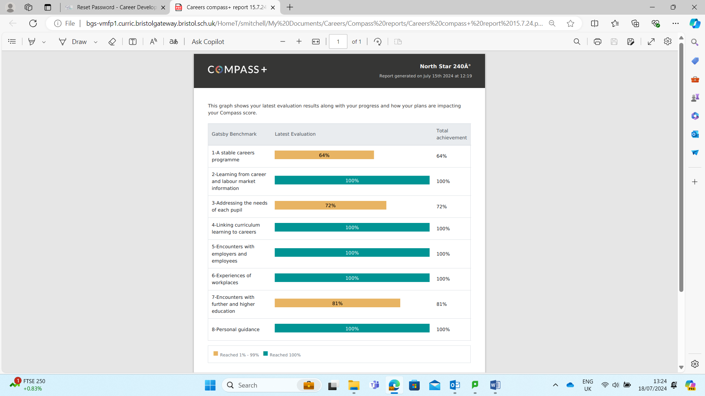

The biggest impacts are seen and heard by our staff and the comments below are indicative of the quantity, quality and intrinsic value of careers education provided at North Star 240:

“*I really enjoyed working at Tyntesfield. I was trusted to do lots of jobs including on the reception desk and on the till in the shop. I really want to go back soon*”. RB

“*It was amazing to go to Mollies Diner. They let us do the jobs rather than just chat to us about them. I think I want to work in a place like this*”. TM

“*The careers advisor was really good. She asked me questions about what I wanted to do and what my dreams were*”. HL

“*I have enjoyed working with Bristol Bears. Its not just about sport, they give us information about college and apprenticeships*”. AW

“*Your students were fantastic. They were interested, engaged and asked questions. They were confident to communicate with the public and complete tasks they were given*”. NT